**APPLICATION LOAD BALNCER:**

Created two EC2 Linux VM (Ec2 instance Name: lb-Demo and lb2- Demo) with Boot- script.

Below is the Script used while creating index.html

#!/bin/bash

yum update -y

yum install httpd -y

service httpd start

chkconfig httpd on

cd /var/www/html

echo "<html><h1>Hello from $(hostname -f)</h1></html>" > index.html

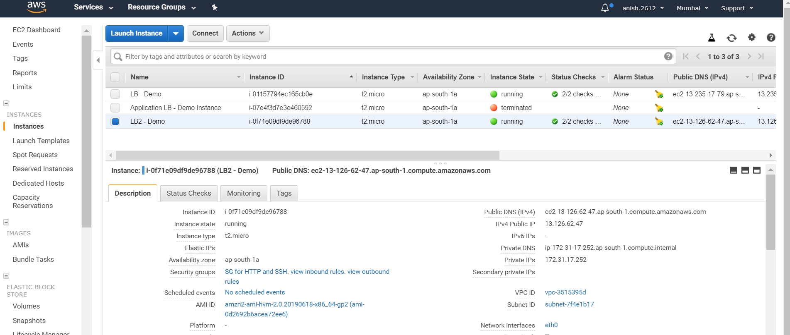

Created Application Load balancer (Application Load balancer) added those two ec2 instances to the load balancer. Added the ec2 instances to those target groups and registered them to the group.

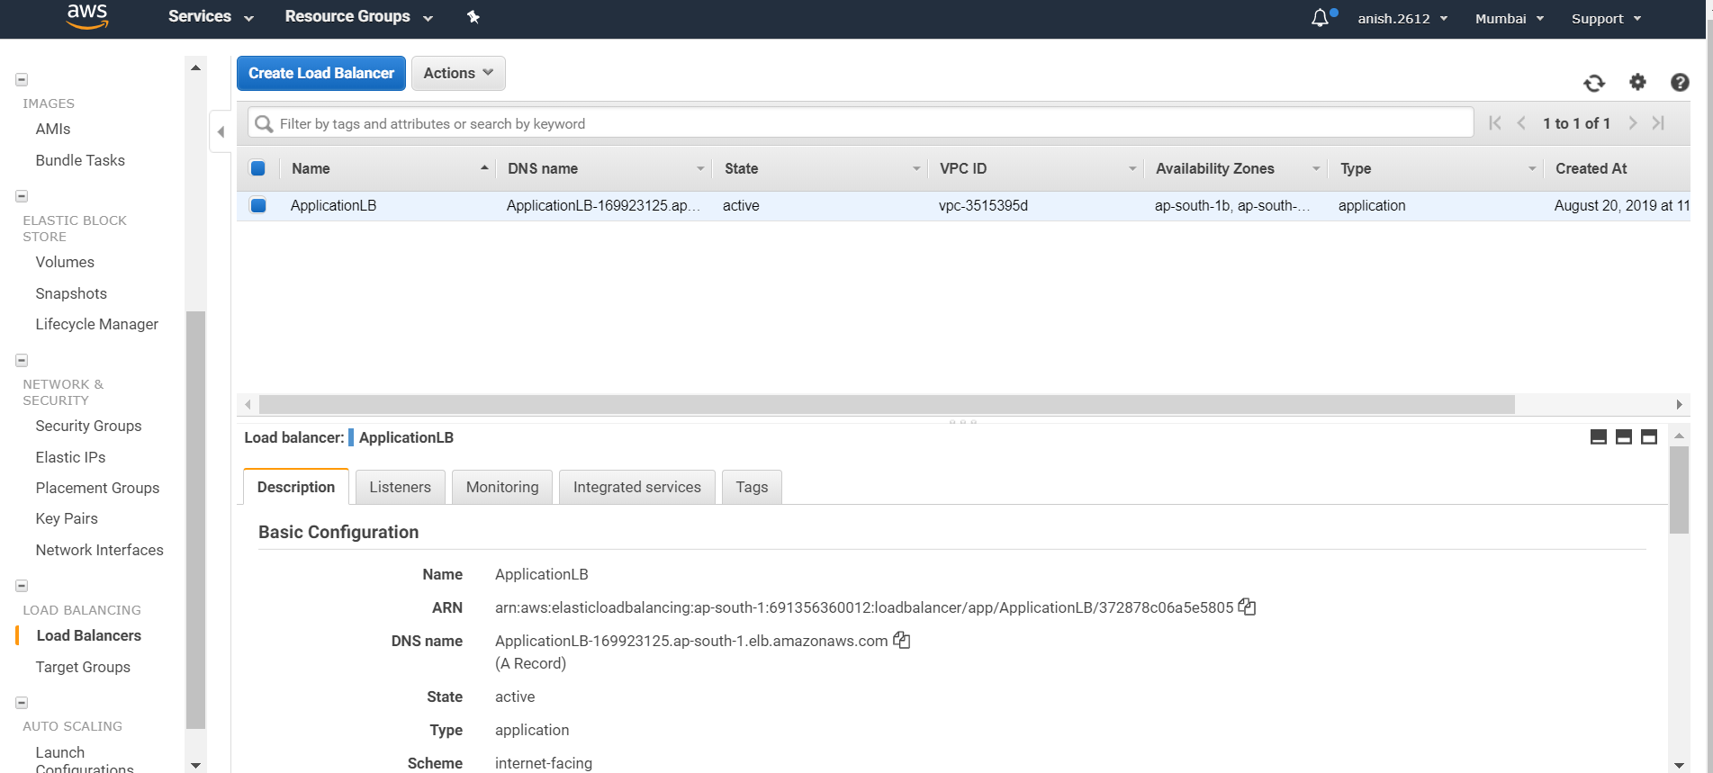

Used the DNS address of the ALB.

As seen in the below screenshot. I do get two different IP ( lb-Demo : Private IP and lb2-demo : Private IP) Each time when I refresh the browser.

